Frequently Asked Questions about Irukandji

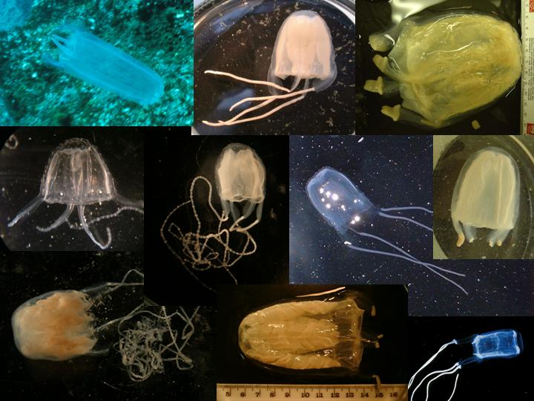

How many speces of Irukandjis are there?
So far, 10 species have been identified which are believed to be capable of giving an Irukandji syndrome to humans. Of these, only 5 are currently named and classified; the other 5 are still being classified by researchers at JCU and AIMS.

How big do they get?
Carukia barnesi is the smallest, with the body reaching only about 1cm tall, and with 4 very fine tentacles up to a meter long; several species get to about an inch tall with tentacles only about 15cm long. One species, which is common on the outer reef, is typically about 12cm tall with tentacles about a half meter long. The largest species, which is very uncommon, reaches about 15cm tall with very thick tentacles to about a half meter.

Are they found on the reefs and islands?
Irukandji syndrome is most often reported from coastal areas, but also occurs at the islands and reefs. The two most severe species in North Queensland occur at the islands and reefs, and the distance from medical care exacerbates the potential for complications. However, both of these more dangerous species are extremely rare.

When are they most likely to occur?
The majority of stings occur coastally in the summertime, in fact, typically in the week between Christmas and New Years Day, and usually confined to a 2 to 3 day period of time. These clusters of stings typically occur when the water is glassy calm, and the north-easterlies have been blowing for a few days or more. However, Irukandji syndrome has been reported, and specimens have been caught, at other times as well, including all months of the year. Stings also sometimes occur when the water is rough, contrary to popular folklore. Irukandjis are thought to occur in large numbers on an offshore current, and be driven in to populated areas by wind currents, tidal movements, and storm events.

Is there any “telltale sign” to look for?
The best indicator is when a lot of sea lice are in the water (sea lice are actually small transparent jellyfish, not insects), or when the jelly buttons can be seen as a glistening band at the high tide line.

How common are Irukandjis?
Relatively speaking, Irukandjis are quite rare. Researchers gather each summertime to harvest as many specimens as they can, and still typically only catch 200-400 specimens on a good year, or just 10-50 on a not-so-good year, and these are typically clustered into one or two 2-day periods.

Are all species of Irukandjis deadly?
Irukandji syndrome appears to group into two main classes, one type which has a mild initial sting and is accompanied by nausea and vomiting, and often has a mild rise in blood pressure; this type of Irukandji syndrome is not thought to be deadly, and is easily controlled by medication and hospital care. The other type has a more severe initial sting, and lacks nausea and vomiting, but often has a critical rise in blood pressure; this type of Irukandji syndrome is thought to be potentially deadly because of the high blood pressure component, and urgent medical care is essential. While it is not completely certain at this point exactly which species of Irukandjis give which type of sting, it is believed that only 3 to 4 of the species fall into the second group.

How many people have died?
Two fatalities have been confirmed from complications arising from Irukandji syndrome, one off Hamilton Island in the Whitsundays, and one at Opal Reef off Port Douglas. Both victims died of cerebral haemorrhage due to complications from high blood pressure caused by the Irukandji syndrome. One of the victims had a previous history of heart problems, while the other was previously healthy. It is widely believed that additional fatalities have occurred which were not attributed to Irukandji syndrome, possibly attributed to drowning, heart failure, stroke, or decompression illness (the bends). Irukandji syndrome leaves no mark on the body, and no chemical or physical signature in the body that can be tested post-mortem.

Can Irukandjis get through the stinger nets?
Several species bodies are smaller than the mesh size of the nets, and therefore, they are able to get through. The nets are designed to keep out the larger box jellyfish, which is extremely dangerous and often swarms along sandy beaches in the summertime. Nets are being developed to exclude Irukandjis as well, but are not currently available. Surf Life Saving monitors patrolled beaches for the presence of Irukandjis and box jellyfish, and closes the beach during high risk times for the safety of the swimming public. However, for those wishing additional protection or peace of mind, wearing of a full-body lycra suit is recommended.

How come so little is known about these things?
Research has been active on Irukandjis since the 1940’s, especially so in the last 20 years with regard to diagnosis and treatment. In the last few years the Irukandji project has attracted large amounts of money and skilled researchers, and we are at a very exciting time now with new discoveries happening at a rapid rate. The main focus of research right now is to identify and classify the species, get them successfully breeding to supply large numbers of specimens, develop reliable methods of prediction and prevention, and develop an antivenom.

How soon will an antivenom be developed?
Research is active right now in two different labs, using two different approaches. It is reasonable to speculate that we will have a usable antivenom in as little as a couple of years.

What should I do if I think I have been stung?
Do not rub the sting area. Douse it with liberal amounts of vinegar as soon as possible. Stay out of the water for about a half hour, or until you are sure that you do not have Irukandji syndrome (the symptoms typically take 5-10 or 20-30 minutes to develop, and can come on very fast). Get help, whether that means notifying a life guard or life saver, or letting someone nearby know that you believe you may have been stung.

What happens during Irukandji syndrome?
The initial sting is typically quite mild and leaves little or no mark, but in some species it can be quite sharp and leave a welt. About 20-30 minutes later (5-10 minutes in some species), the patient begins to feel any or all of the following: severe lower back pain, nausea and vomiting, powerful stomach cramps, shooting spasms in the limbs, profuse sweating, difficulty breathing, and a feeling of impending doom. This type of syndrome is not regarded as life threatening in healthy people, although medical care is important for the comfort of the patient. Some species may cause extremely high blood pressure (hypertension), which can cause stroke or heart failure in people without pre-existing medical problems; this type of syndrome is rare but is considered life threatening, and urgent hospital care is essential. Thus, medical attention is important for all cases of Irukandji syndrome. If in doubt, call an ambulance or seek medical aid.

What is the best prevention method?
A full-body lycra suit provides excellent protection against jellyfish stings, covering about 75-80% of the body’s skin surface. It is still possible to be stung on the hands, feet, or face, but stings in these places occur far less often than stings on the upper body, or arms or legs. It is also possible to crush a tentacle or body part of a jellyfish through the mesh of the lycra suit, but this is extremely rare in recreational contexts, occurring more often in industrial situations. Furthermore, lycra suits also provide excellent UV protection from the sun.

